# **Set up a Microsoft 365 E5 Trial subscription**

Lab environment Setup guide

Published: Feb 11, 2020

Table of Contents

**Set up a Microsoft 365 E5 Trial subscription** 1

**Lab: Setting up your environment** 2

# **Lab: Setting up your environment**

**Exercise 1: Sign Up for an Office 365 E5 Trial**

In this exercise, you will sign up for an Office 365 E5 Trial tenant for use during the workshop.

**Tasks**

1. Browse to <https://go.microsoft.com/fwlink/p/?LinkID=698279&culture=enUS&country=US>
2. For Sign Up [Office 365 E5](https://go.microsoft.com/fwlink/p/?LinkID=698279&culture=en-US&country=US) Trial Login with your work or school credentials. Click Next

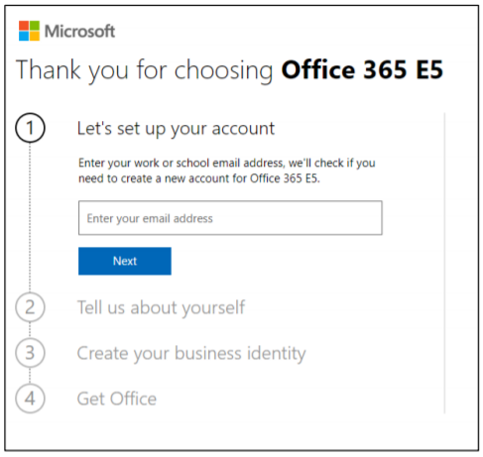

1. Enter your Personal details and click **Next** to proceed.

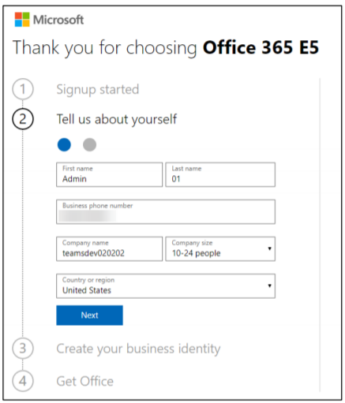

1. After **Personal Details** it will ask for **verification code** which is sent to you provided **Phone no**. Insert the same to proceed.

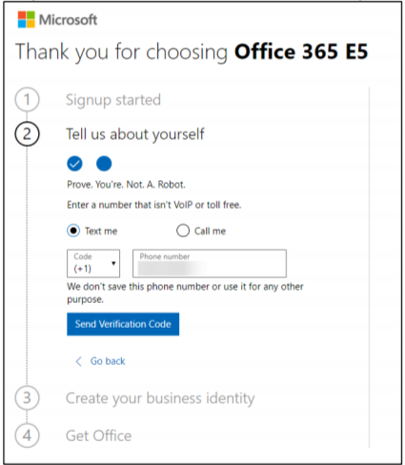

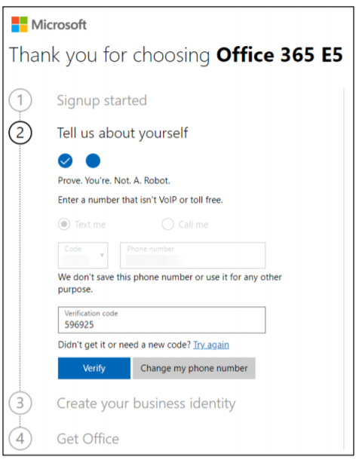

1. In Next step provide a tenant name like **TeamsDev######** where **######** is any random unique 6-digit number.
   1. So your admin user ID will be [admin@teamsdev######.onmicrosoft.com](mailto:admin@teamsdev######.onmicrosoft.com)

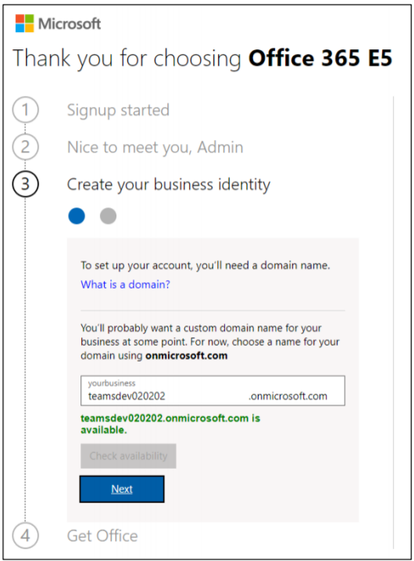

1. Now Check the availability of desired username and then click **Next**.
2. Insert **Username** and **Password** in the below fields for Sign Up.

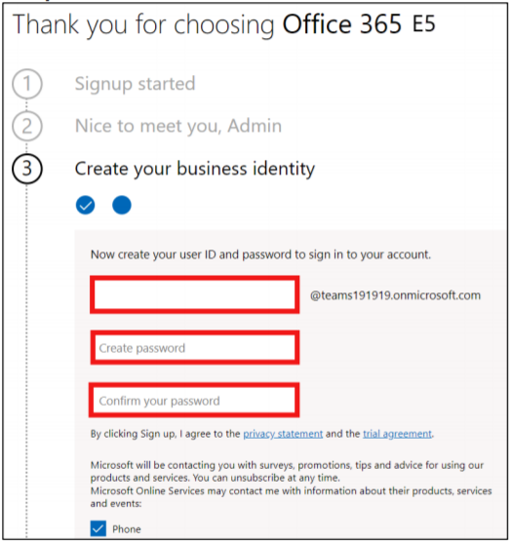

1. Account is created Go to the Set Up.

